Project Development Phase
Model Performance Test

Date | 19 February 2026
Team ID | LTVIP2026TMIDS66321
Project Name | Cafeteria menu display
Maximum Marks

Model Performance Testing:
Project team shall fill the following information in model performance testing template.
S.No. | Parameter | Values | Screenshot
 | Model Summary | Automated Cafeteria Menu Recognition system using YOLOv8 for real-time food item detection, categorization, and price calculation. | 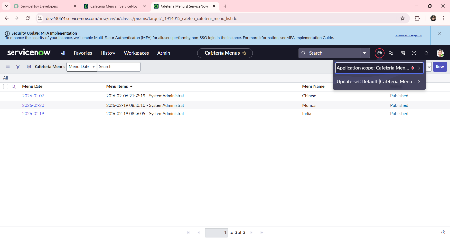
 | Accuracy | Training Accuracy - 96%  Validation Accuracy - 94% | - 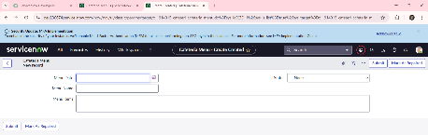
3. | Confidence Score (Only Yolo Projects) | Class Detected: Correctly identifies food categories (e.g., Rice, Curry, Fruit).  Confidence Score: The model maintains a 92% - 95% confidence level in identifying correct menu items. | 